|  |  |  |  |  |  |  |
| --- | --- | --- | --- | --- | --- | --- |
| VILNIAUS KOLEGIJA  UNIVERSITY OF APPLIED SCIENCES  FACULTY OF ELECTRONICS AND INFORMATICS  Image result for viko logo | | |  | | | VILNIUS COLLEGE  Image result for viko logoFACULTY OF ELECTRONICS AND INFORMATICS |
|  | | |  | | |  |
| **SMART DEVICE SENSORS PROGRAMMING** | | |  | | | **INTRODUCTION TO INFORMATICS** |
| LABORATORY WORK  LABORATORY WORK NR.: 7  6531BX028 PI18E | | |  | | | PRACTICAL ASSIGNMENT  SPOTIFY USER MANUAL  6531BX028 PI18E |
| STUDENT | DŽIUGAS PEČIULEVIČIUS | STUDENT | | DŽIUGAS PEČIULEVIČIUS |
| (SIGNATURE)  3/19/2021 | | |  | | | LECTURER |
| LECTURER | SIMONAS ČESNAUSKAS | (SIGNATURE)  10/17/2018 | | VIRGILIJUS KUKLIERIUS |
| (SIGNATURE)  3/19/2021 | | |  | | | 2018 |

2021

Work objective:

Gain practical knowledge of the structure of the hardware C program and learn how to control point indicators with a microprocessor controller.

Tasks:

* Answer the questions below in your own words *(if possible)*;
* Prepare a report of laboratory work in accordance with the methodological instructions of Vilnius Kolegija, EIF for final theses (appropriate title page, text alignment, font size, line spacing, etc.).
* The file name must be as follows „ LW_07_J.Smith“.
* Learn to make an electrical circuit with an Arduino controller.
* Learn how to create program code and write it to the controller.
* Learn to output information to a computer.
* Learn to apply ARDUINO analog and digital inputs.

Tasks:

1. **Generate software code that can output ASCII table characters (at least 3 characters) and their numeric codes in decimal and hexadecimal formats on a computer screen (serial monitor).**
   1. Establish a consistent interface for computer communication.
   2. Generate program code that would output the ASCII (Figure 1) character and its decimal and hexadecimal codes to the serial monitor window on separate lines.
   3. Repeat the output cycle until at least 3 ASCII table characters are output.

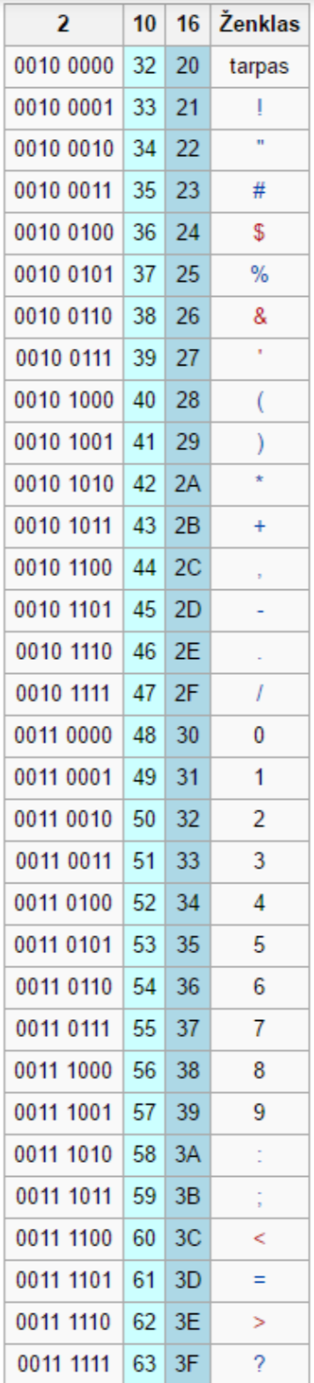

Answers:

1. char asciiCode = 32;
2. // the first 32 characters in the ASCII-table are unprintable control codes and are used to control peripherals such as printers
3. void setup() {
4. // code setup to run once (initialize the digital pin as an output)
5. // if we would connect more LEDs, we would need to setup each pin here
6. Serial.begin(9600);
7. Serial.println(“\n\n Binary, DEC, HEX, Symbol”); // header
8. }
9. void loop() {
10. if(asciiCode < 64) { // check if asciiCode is below 64
11. Serial.print(asciiCode, BIN); // print ascii binary
12. Serial.print(“\t”); // space
13. Serial.print(asciiCode, DEC); // print ascii decimal
14. Serial.print(“\t”); // space
15. Serial.print(asciiCode, HEX); // print ascii hexadecimal
16. Serial.print(“\t”); // space
17. Serial.print(asciiCode); // print ascii char itself
18. asciiCode++; // go through the loop
19. }
20. }

Output:

